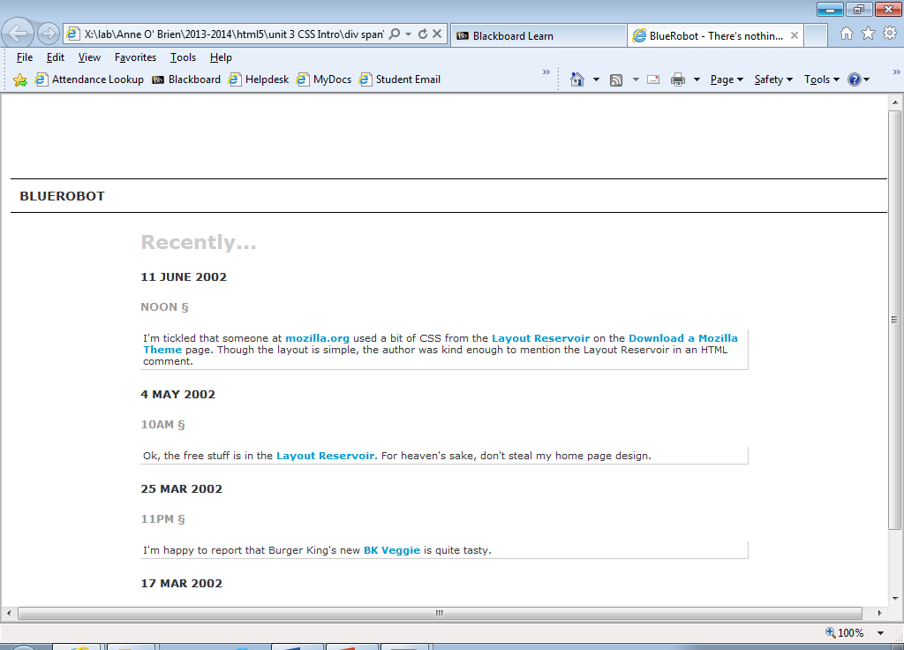

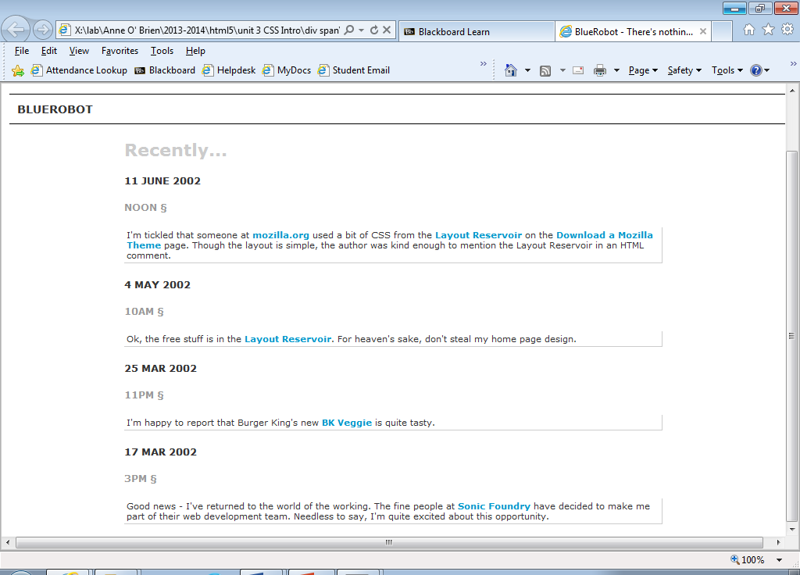

Colours used:

color:#333;

color:#ccc; color:#999;

font-family:verdana, arial, helvetica, sans-serif;

**Recently...**

**11 JUNE 2002**

**NOON §**

I'm tickled that someone at **mozilla.org** used a bit of CSS from the **Layout Reservoir** on the **Download a Mozilla Theme** page. Though the layout is simple, the author was kind enough to mention the Layout Reservoir in an HTML comment.

**4 MAY 2002**

**10AM §**

Ok, the free stuff is in the **Layout Reservoir**. For heaven's sake, don't steal my home page design.

**25 MAR 2002**

**11PM §**

I'm happy to report that Burger King's new **BK Veggie** is quite tasty.

**17 MAR 2002**

**3PM §**

Good news - I've returned to the world of the working. The fine people at **Sonic Foundry** have decided to make me part of their web development team. Needless to say, I'm quite excited about this opportunity.